Step-by-Step: Process Order from Estimate

| August-20 |

**Document Overview**

**Documentation Goals**

This documentation is intended to provide instruction for ***(XYZ – REPLACE WITH DOC Function)****.*

**Documentation Disclaimers**

* Teach a user how to utilize or develop in Progress.
* Provide instructions for creating or administering and Advantzware Progress Database.
* Provide application Support for other Advantzware functions.

**Special Terminology**

* ***REPLACE/LIST any special terminology for the document***

**Table of Contents**

**Process Order from Estimate** 4

Cost Estimating 4

Step One: Open the Desired Estimate Screen 4

Step Two: Add a New Estimate 5

Step Three: Enter Estimate Information 5

Step Four: Save Estimate 5

Step Five: Verify Specs Information 6

Step Six: Verify All Other Tabs 6

Step Seven: Calculate Costs 7

Quotations 7

Step One: Open the Quote Screen 7

Step Two: Add a New Quote 8

Step Three: Enter Estimate 9

Step Four: Date and Contact Information 9

Step Five: Address Information 10

Step Five: Save Quote 11

Step Six: Print Quote 12

Order Processing – Order Entry 13

Step One: Open Order Maintenance Screen 13

Step Two: Add a New Order 14

Step Three: Enter Estimate 15

Step Four: Verify Order Information 16

Step Five: Save Order 16

Purchasing 17

Add Purchase Orders 17

Print Purchase Orders 19

Raw Materials 21

New Raw Materials 21

Material Receipts 24

Post Receipt Transactions 26

Quantity Issues 28

Post Issue Transactions 30

Production Control 32

Heading3 32

Heading3 32

Heading3 32

Heading3 32

Heading3 32

Heading3 32

Heading3 32

Finished Goods Control 32

Heading3 32

Heading3 32

Order Processing – Releases (Optional) 33

Release an Item 33

Find the Release 36

Print Pick Ticket 39

Post Pick Ticket 40

Order Processing – Bills of Lading 42

Locate Bill of Lading 42

Post Bill of Lading 44

Order Processing – Invoicing 45

Locate Invoice 45

Print Invoice 46

Post Invoice 47

# **Process Order from Estimate**

## Cost Estimating

The user should create or choose an Estimate for either Folded boxes, or Corrugated boxes.

### Step One: Open the Desired Estimate Screen

#### Folding Estimates

The *Folding Estimates* screen is located in the following Menu Path: Estimating/Quotes -> Folding Estimates. Alternatively, the user can quickly get to this screen using Hot Key combination: ***[“E” – “F”]***.

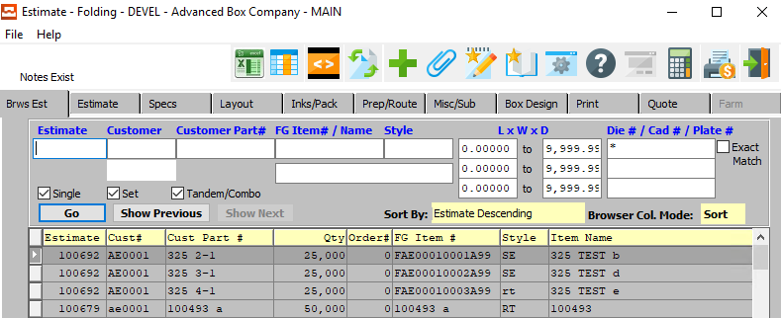

#### Corrugated Estimates

The *Corrugated Estimates* screen is located in the following Menu Path: Estimating/Quotes -> Corrugated Box Estimate. Alternatively, the user can quickly get to this screen using the Hot Key combination: ***[“E” – “C”]***.

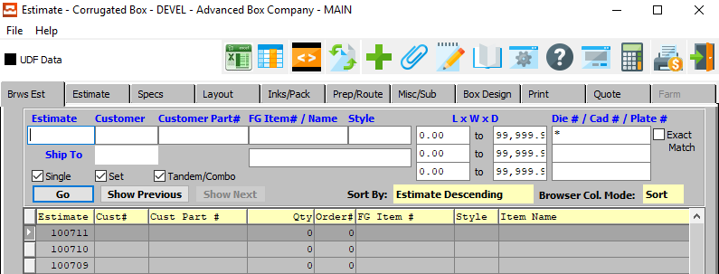

### Step Two: Add a New Estimate

To add a new estimate, the user can quickly press the ***“Green + Icon”*** at the top to the screen.



Alternatively, the user can move to the *Estimate* tab, and click the ***“Add”*** button at the bottom of the screen.

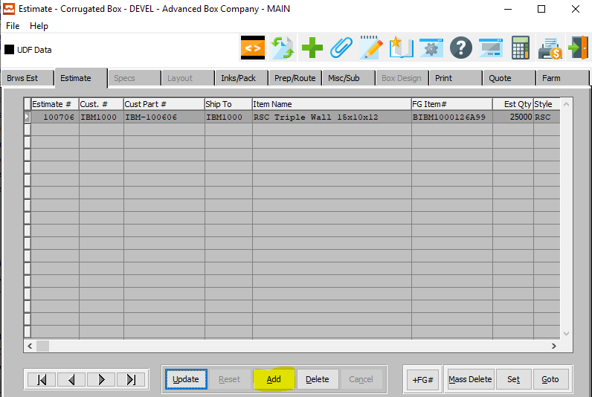

The new order will automatically be given an Order Number by the system, which is not modifiable by the user here.



### Step Three: Enter Estimate Information

The user may now take this opportunity to fill out all necessary data fields pertaining to this Estimate. For any questions concerning specific Estimate Fields, the user may refer to one of the ***“Estimate Manuals”***.

### Step Four: Save Estimate

Once the user is satisfied with all of the information within this new order, they may click the ***“Save”*** button at the bottom of the screen to save the order to the system.



### Step Five: Verify Specs Information

Once the user has entered valid Estimate information, all of that Estimate’s relevant Spec information will populate within the fields on the *Specs* tab.

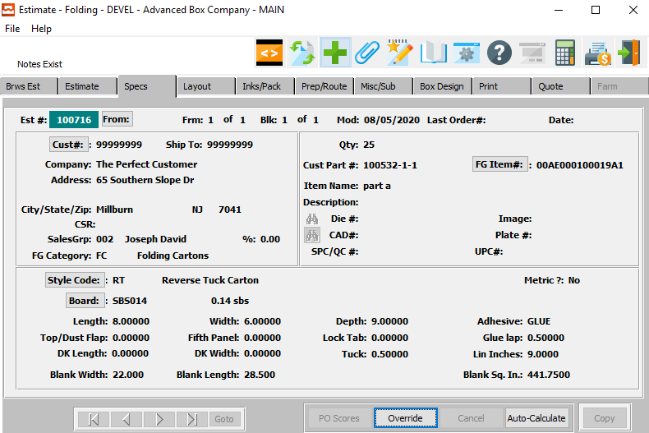

The user may now take this opportunity to update or change any available Spec Fields. For any questions concerning specific Spec Fields, the user may refer to one of the ***“Estimate Manuals”***.

To change Spec information, the user may click the ***“Override”*** button at the bottom of the page.



#### Save Spec Changes

Once the user is satisfied with all of the information within the Spec fields for this Estimate, they may click the ***“Save”*** button at the bottom of the screen to save the Spec information to the system.



### Step Six: Verify All Other Tabs

Once the user has entered valid Estimate information, all of that Estimate’s relevant information will populate within the fields on the other tabs within the Estimate screen. Following the above example for the *Specs* tab, the user may verify and update any desired information on any of the remaining tabs for the Estimate.

### Step Seven: Calculate Costs

Once all of the desired style, materials, and machine operations have been added and adjusted to the user’s satisfaction, the user may press the ***“Auto-Calculate”*** button in order to calculate the cost estimate.

This button is located on both the *Specs* and *Layout* screens.



## Quotations

### Step One: Open the Quote Screen

The *Quote Maintenance* screen is located in the following Menu Path: Estimating/Quotes -> Quotes. Alternatively, the user can quickly get to this screen using the Hot Key combination: ***[“E” – “Q”]***.

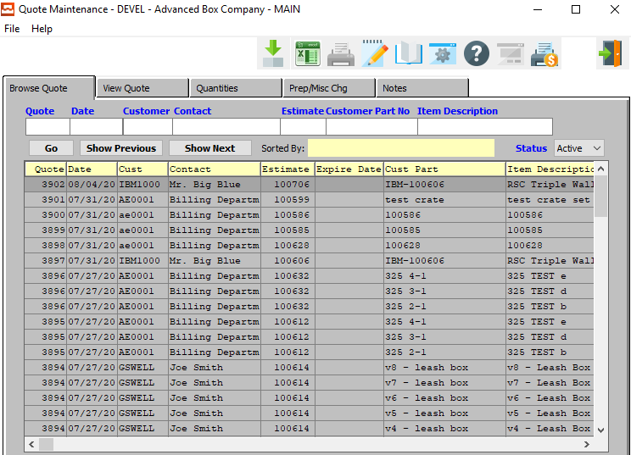

### Step Two: Add a New Quote

To add a new order, the user can move to the *View Quote* tab, and click the ***“Add”*** button in the middle of the screen.

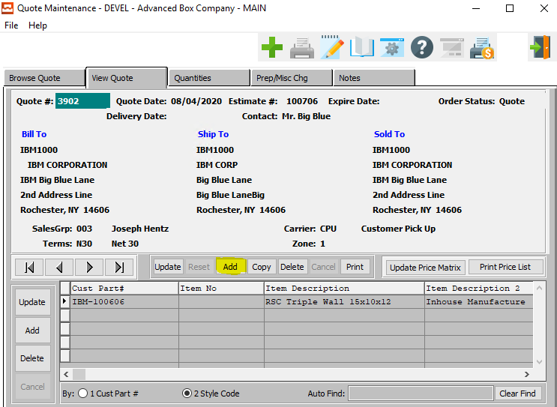

The new quote will automatically be given an Quote Number by the system, which is not modifiable by the user here.



### Step Three: Enter Estimate

The user must now enter an Estimate Number to base this new quote on. If the user knows the Estimate Number that they wish to use, they may enter it manually in the *Estimate #* field.



Alternatively, the user can press the ***“F1”*** key to choose a number from a list of available Estimate Information.

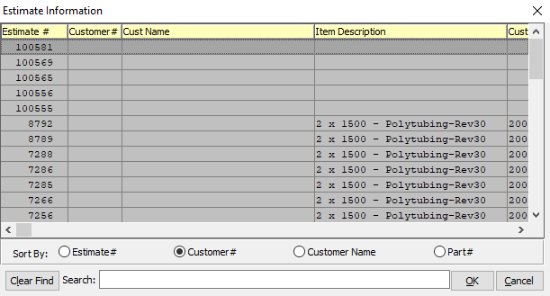

This list can be sorted by Estimate Number, Customer Number, Customer Name, or Part Number. Alternatively, the user may search for any estimate that they wish to use in order to narrow down their selection.

In order to choose the desired Estimate from this list, the user may double-click on the desired Estimate line. Alternatively, the user may click on their desired Estimate Line in order to highlight it within the list, then click the ***“OK”*** button at the bottom of the *Estimate Information* screen. Only a highlighted Estimate will populate within the new quote.

### Step Four: Date and Contact Information

The user must now enter an Expiration Date and Delivery Date for this particular quote. They should also enter the name of the contact for this quote. There are no lookup options available for these fields.

### Step Five: Address Information

The user must now enter the Bill-To, Ship-To, and Sold-To address information for this quote. If the user knows the information that they wish to use, they may enter it manually in the individual fields.

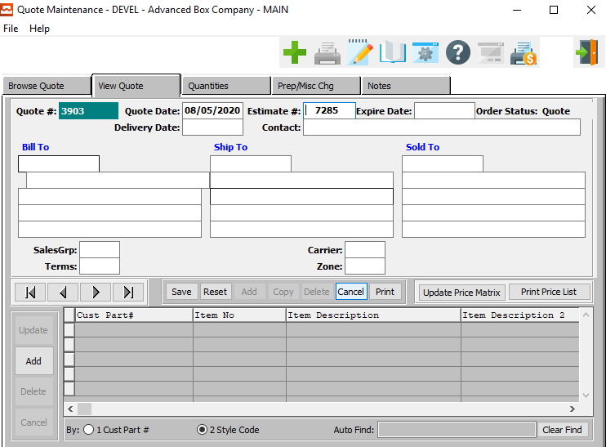

Alternatively, the user can press the ***“F1”*** key with their cursor in the *Bill-*To field in order to choose the information from a list of available Customer Information.

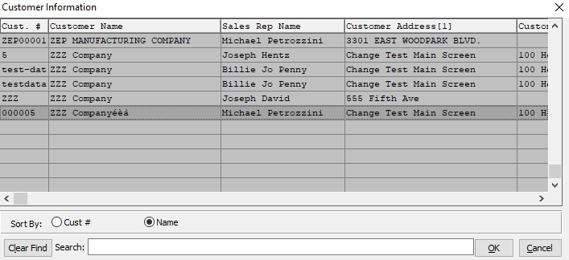

This list can be sorted by Customer Number or Customer Name. Alternatively, the user may search for any customer that they wish to use in order to narrow down their selection.

In order to choose the desired Customer from this list, the user may double-click on the desired Customer line. Alternatively, the user may click on their desired Customer Line in order to highlight it within the list, then click the ***“OK”*** button at the bottom of the *Customer Information* screen. Only a highlighted Customer will populate within the new quote.

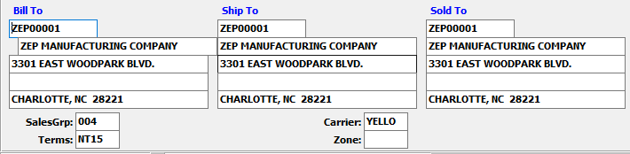

Once the user has entered or chosen a valid Customer, all of that Customer’s relevant address information will populate within the Quote fields.

The user may now take this opportunity to update or change any available Quote Fields. For any questions concerning specific Quote Fields, the user may refer to one of the ***“Estimate Manuals”***.

### Step Five: Save Quote

Once the user is satisfied with all of the information within this new quote, they may click the ***“Save”*** button in the middle of the screen to save the quote to the system.



### Step Six: Print Quote

Once in the Quote File, the user may click the ***“Print”*** button to print a quote for their client.



A print selection screen will pop up for the user, which will allow printing, faxing, viewing, or emailing the quote form.

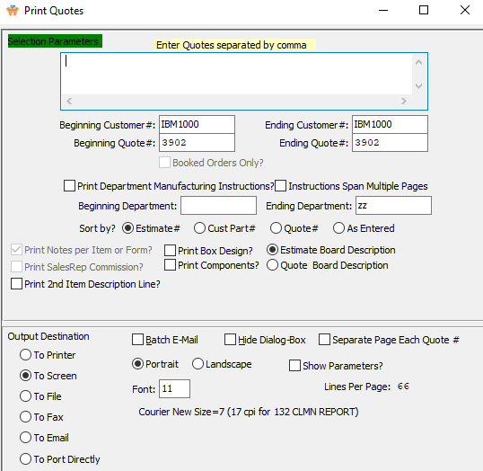

## Order Processing – Order Entry

### Step One: Open Order Maintenance Screen

The *Order Maintenance* screen is located in the following Menu Path: Order Processing -> Update/Add Orders -> Order Entry. Alternatively, the user can quickly get to this screen using the Hot Key combination: ***[“O” – “U” – “1”]***.

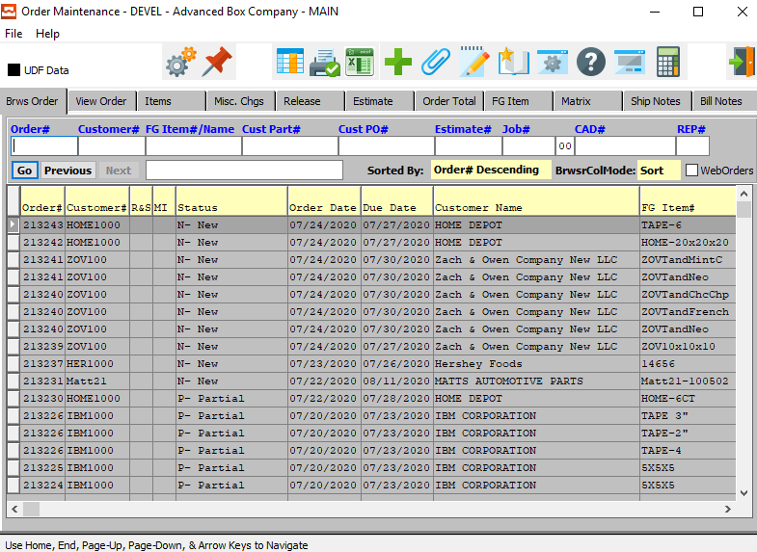

### Step Two: Add a New Order

To add a new order, the user can quickly press the ***“Green + Icon”*** at the top to the screen.



Alternatively, the user can move to the *View Order* tab, and click the ***“Add”*** button at the bottom of the screen.

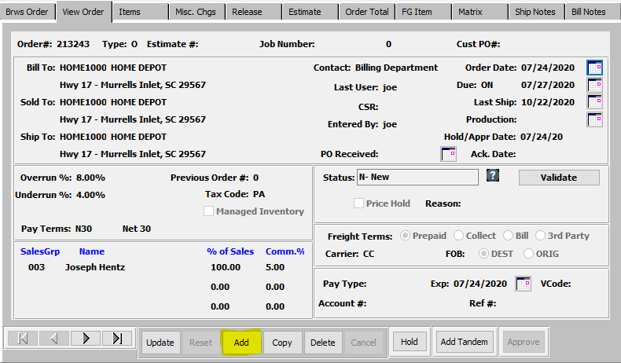

The new order will automatically be given an Order Number by the system, which is not modifiable by the user here.



### Step Three: Enter Estimate

The user must now enter an Estimate Number to base this new order on. If the user knows the Estimate Number that they wish to use, they may enter it manually in the *Estimate #* field.



Alternatively, the user can press the ***“F1”*** key to choose a number from a list of available Estimate Information.



This list can be sorted by Estimate Number, Customer Number, Customer Name, or Part Number. Alternatively, the user may search for any estimate that they wish to use in order to narrow down their selection.

In order to choose the desired Estimate from this list, the user may double-click on the desired Estimate line. Alternatively, the user may click on their desired Estimate Line in order to highlight it within the list, then click the ***“OK”*** button at the bottom of the *Estimate Information* screen. Only a highlighted Estimate will populate within the new order.

### Step Four: Verify Order Information

Once the user has entered or chosen a valid Estimate Number, all of that Estimate’s relevant information will populate within the Order fields.

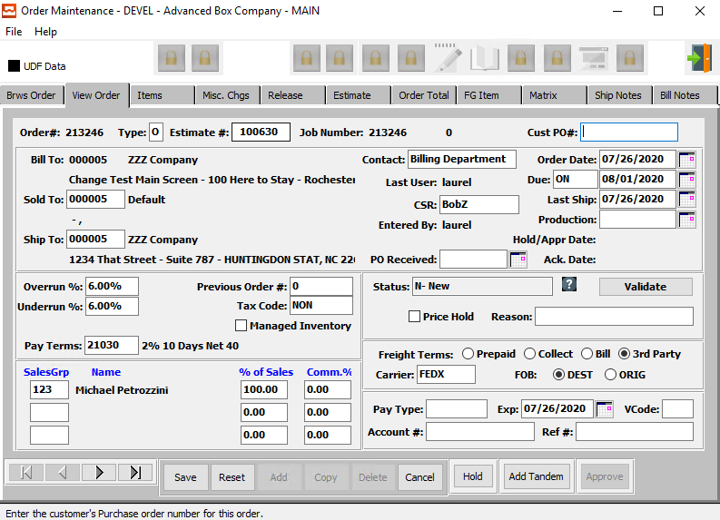

The user may now take this opportunity to update or change any available Order Fields. For any questions concerning specific Order Fields, the user may refer to the ***“Order Processing Manual”***.

### Step Five: Save Order

Once the user is satisfied with all of the information within this new order, they may click the ***“Save”*** button at the bottom of the screen to save the order to the system.



## Purchasing

### Add Purchase Orders

#### Step One: Open Purchase Order Screen

The *Purchase Order* screen is located in the following Menu Path: Purchasing -> Update/Enter Purchase Order -> Enter/Edit PO’s. Alternatively, the user can quickly get to this screen using the Hot Key combination: ***[“P” – “U” – “1”]***.

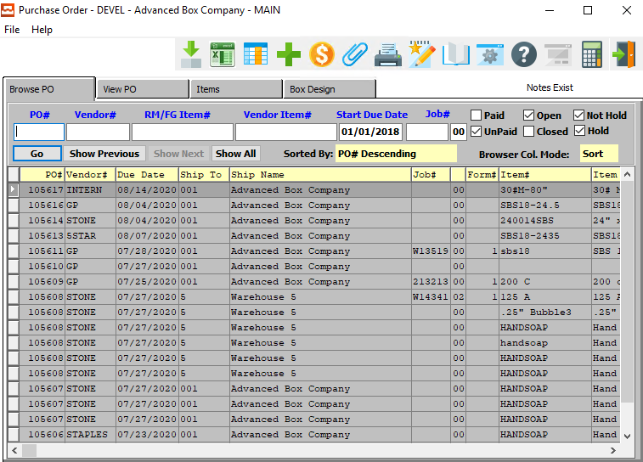

Purchase Orders may be added for Finished Goods for *Farm Out Jobs* or Raw Materials. The Raw Materials may be estimated or real-stocked raw goods. Ordering real materials requires creating unique items in the *Raw Materials File Maintenance* with actual width and lengths. Ordering estimated materials will not require creating unique items.

Please Note: Only real material will track a perpetual inventory. Estimated materials are purchased and consumed for a specific job. Once the job number is entered, the width, length and scoring allowance are transferred to the purchase order.

#### Step Two: Add a New Purchase Order

To add a new Purchase Order, the user can quickly press the ***“Green + Icon”*** at the top to the screen.



Alternatively, the user can move to the *View PO* tab, and click the ***“Add”*** button at the bottom of the screen.

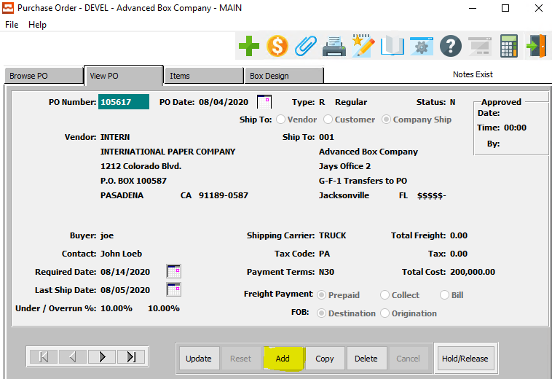

The new order will automatically be given an Order Number by the system, which is not modifiable by the user here.



#### Step Three: Review Purchase Order Information

The user may now take this opportunity to update or change any available Purchase Order Fields. For any questions concerning specific Purchase Order Fields, the user may refer to the ***“Purchasing Manual”***.

#### Step Four: Save Purchase Order

Once the user is satisfied with all of the information within this new purchase order, they may click the ***“Save”*** button at the bottom of the screen to save the purchase order to the system.



### Print Purchase Orders

#### Step One: Open Printing Screen

The *Print Purchase Orders* screen is located in the following Menu Path: Purchasing -> Update/Enter Purchase Orders -> Print PO’s. Alternatively, the user can quickly get to this screen using the Hot Key combination: ***[“P” – “U” – “3”]***.

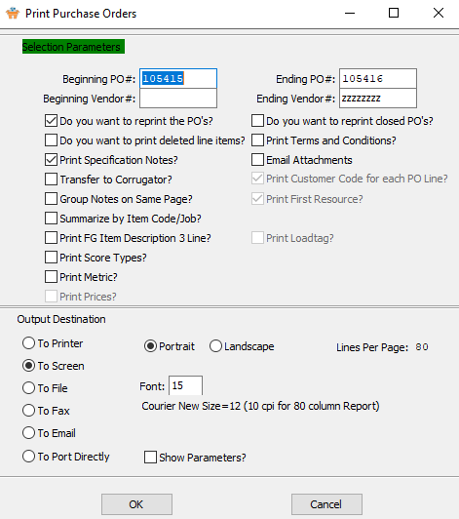

#### Step Two: Print Selected Purchase Orders

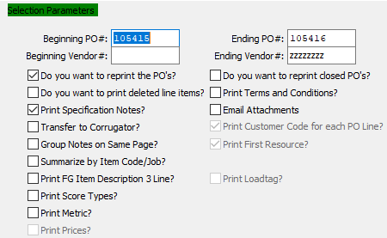

The user may now input their selection parameters as to which purchase orders they wish to print. Multiple purchase orders can be printed at the same time, as the user can enter the beginning and ending selections into their desired fields. Purchase Orders within those parameters will print tickets.

If the user is attempting to reprint Purchase Orders that have previously been printed, they must make sure that the *Do you want to reprint the PO’s* toggle box is checked.

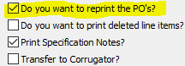

The user may now take this opportunity to check any toggle boxes for other special rules that they with the tickets to follow. For any questions concerning specific rules, the user may refer to the ***“Purchasing Manual”***.

#### Step Three: Send Board Orders to Corrugator

If the user is attempting to send Board Orders to a Corrugator, they must make sure that the *Transfer to Corrugator* toggle box is checked.

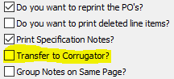

Please Note: The EDI field must be checked in the vendor file and the ***N-K-POEXPORT*** character value must be set to the appropriate corrugated scheduling software.

## Raw Materials

### New Raw Materials

Purchase orders for real stocked raw materials must first be created in the *Raw Material File*. To speed this process, the ***“Copy”*** key should be used by copying an estimated material to a new raw material item code.

#### Step One: Open the Desired Raw Material Maintenance Screen

##### Folding Carton Materials

The *Raw Materials Inventory* screen for Folding Carton Materials is located in the following Menu Path: Materials/Raw Goods -> File Maintenance for Raw Goods -> Folding Carton Materials. Alternatively, the user can quickly get to this screen using Hot Key combination: ***[“M” – “F” – “1”]***.

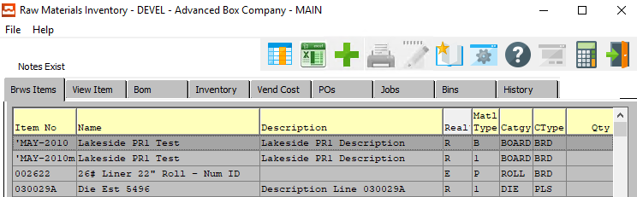

##### Corrugated/Foam Materials

The *Raw Materials (Corrugated)* screen is located in the following Menu Path: Materials/Raw Goods -> File Maintenance for Raw Goods -> Corrugated/Foam Materials. Alternatively, the user can quickly get to this screen using Hot Key combination: ***[“M” – “F” – “2”]***.

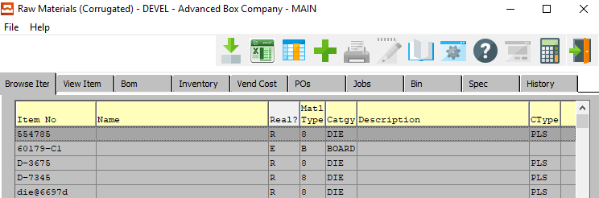

#### Step Two: Add a New Raw Material

To add a new Raw Material, the user can quickly press the ***“Green + Icon”*** at the top to the screen.



Alternatively, the user can move to the *View Item* tab, and click the ***“Add”*** button at the bottom of the screen.

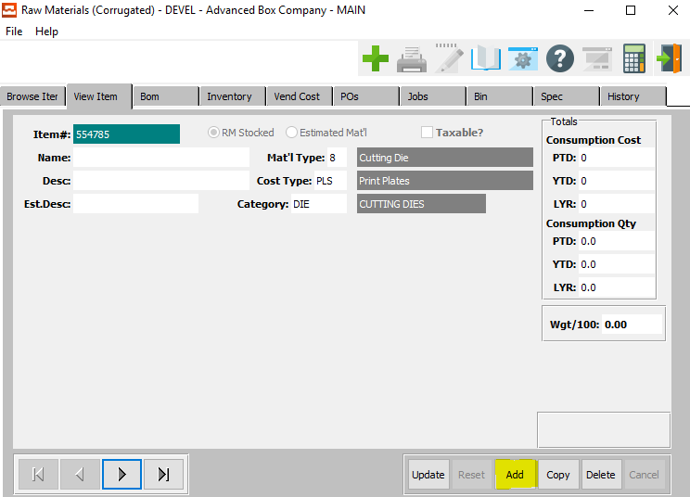

#### Step Three: Enter New Item Information

The user must now enter a unique Item Number for this new Raw Material in the *Item #* field.

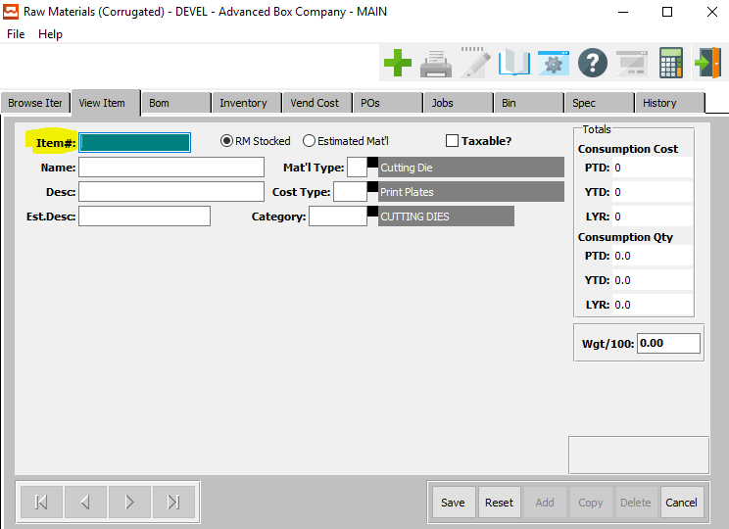

The user may now take this opportunity to update or change any available Raw Material Fields. For any questions concerning specific Raw Material Fields, the user may refer to the ***“Raw Materials Manual”***.

#### Step Four: Saw Raw Material

Once the user is satisfied with all of the information within this new order, they may click the ***“Save”*** button at the bottom of the screen to save the raw material to the system.



### Material Receipts

Receipts for both estimated and raw materials must be entered for the exact quantity received. The purchase order number should be entered so that the system will decide to close the PO if the quantity received is within the underrun percentage of the order quantity.

#### Step One: Open the Warehouse Transaction Receipts Screen

The *Warehouse Transaction Receipts* screen is located in the following Menu Path: Materials/Raw Goods -> Update Materials Transactions -> RM Enter/Modify Receipts. Alternatively, the user can quickly get to this screen using the Hot Key combination: ***[“M” – “U” – “1”]***.

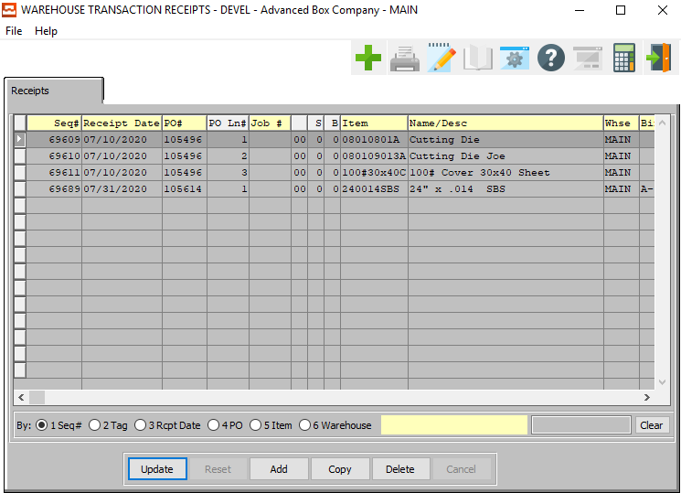

#### Step Two: Add a New Receipt

To add a new receipt, the user can quickly press the ***“Green + Icon”*** at the top to the screen.



Alternatively, the user can click the ***“Add”*** button at the bottom of the screen.

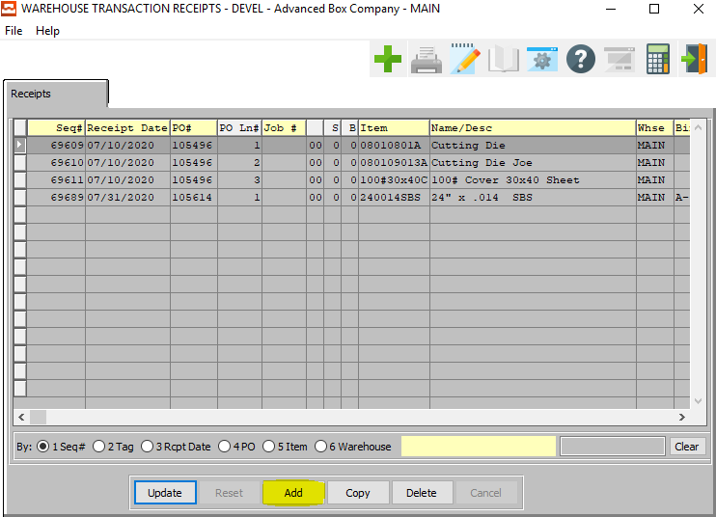

The new receipt will automatically be given a Sequence Number by the system, which is not modifiable by the user.

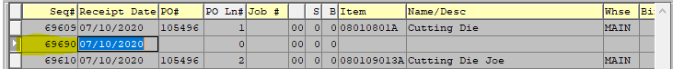

#### Step Three: Verify Receipt Information

The user may now take this opportunity to update or change any available Receipt Fields. For any questions concerning specific Receipt Fields, the user may refer to the ***“Raw Materials Manual”***.

#### Step Four: Save Receipt

Once the user is satisfied with all of the information within this new receipt, they may click the ***“Save”*** button at the bottom of the screen to save the order to the system.



### Post Receipt Transactions

#### Step One: Open Raw Material Post Screen

The *Raw Material Post* screen is located in the following Menu Path: Materials/Raw Goods -> Update Materials Transactions -> Post to Raw Material Files. Alternatively, the user can quickly get to this screen using the Hot Key combination: ***[“M” – “U” – “6”]***.

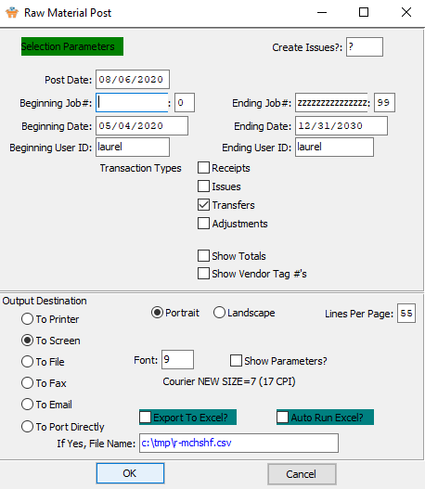

#### Step Two: Post Selected Receipt

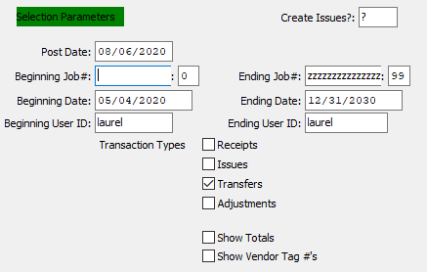

The user may now input their selection parameters as to which receipts they wish to post. Multiple receipts can be posted at the same time, as the user can enter the beginning and ending selections into their desired fields.

However, the user must make sure that the *Receipts* toggle box is checked in order to do so. Receipts within those parameters will post to Raw Material files.

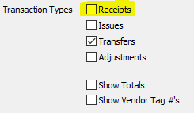

The user may now take this opportunity to check any toggle boxes for other special rules that they with the tickets to follow. For any questions concerning specific rules, the user may refer to the ***“Raw Materials Manual”***.

Raw material receipt transactions must be posted to update the job cost work in process costs as well as update quantity on hand.

### Quantity Issues

Issues of materials purchased for a specific job number will automatically issue the quantity received to the job cost if the ***N-K-AUTOISSU*** flag is set to ***“Yes”***.

If this flag is set to ***“No”***, the quantity issues must be entered via the *Issue Materials to Jobs* program.

Please Note: Receipts will be automatically issued only if the receipt has a purchase order and the purchase order has a job number assigned. Therefore, board purchased for stock without a job number will require both raw material receipt transaction and a separate raw material issue transaction.

#### Step One: Open XXX Screen

The *Warehouse Transaction Issues* screen is located in the following Menu Path: Materials/Raw Goods -> Update Materials Transactions -> Issue Materials to Jobs. Alternatively, the user can quickly get to this screen using the Hot Key combination: ***[“M” – “U” – “2”]***.

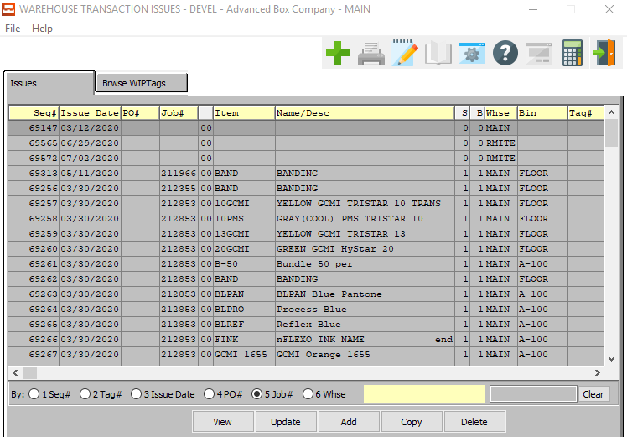

#### Step Two: Add New Issue

To add a new Quantity Issue, the user can quickly press the ***“Green + Icon”*** at the top to the screen.



Alternatively, the user can click the ***“Add”*** button at the bottom of the screen.



The new issue will automatically be given a Sequence Number by the system, which is not modifiable by the user.

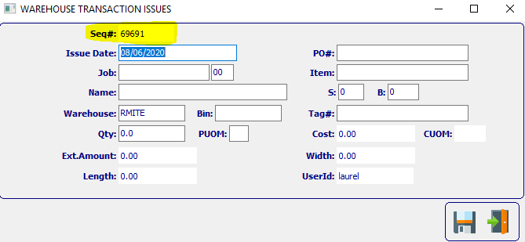

#### Step Three: Verify Issue Information

The user may now take this opportunity to update or change any available Issue Fields. For any questions concerning specific Issue Fields, the user may refer to the ***“Raw Materials Manual”***.

#### Step Four: Save Issue

Once the user is satisfied with all of the information within this new issue, they may click the ***“Floppy Disc Icon”*** button at the bottom of the screen to save the order to the system.



### Post Issue Transactions

Raw material issue transactions must be posted to update the job cost work in process costs as well as update quantity on hand.

#### Step One: Open Raw Material Post Screen

The *Raw Material Post* screen is located in the following Menu Path: Materials/Raw Goods -> Update Materials Transactions -> Post to Raw Material Files. Alternatively, the user can quickly get to this screen using the Hot Key combination: ***[“M” – “U” – “6”]***.



#### Step Two: Post Selected Issue



The user may now input their selection parameters as to which issues they wish to post. Multiple issues can be posted at the same time, as the user can enter the beginning and ending selections into their desired fields.

However, the user must make sure that the *Issues* toggle box is checked in order to do so. Issues within those parameters will post to Raw Material files.

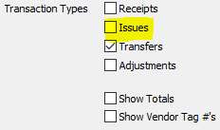

The user may now take this opportunity to check any toggle boxes for other special rules that they with the tickets to follow. For any questions concerning specific rules, the user may refer to the ***“Raw Materials Manual”***.

## Production Control

### Production Usage

Machine setup, run, and downtime hours as well as waste should be posted for each machine operation. The actual hours posted, and quantity produced will be compared to the job cost standards to generate job cost variances and labor efficiency reporting.

#### Step One: Open Production Usage Screen

The *Production Usage* screen is located in the following Menu Path: Data Collection -> Floor Reporting at Machine. Alternatively, the user can quickly get to this screen using Hot Key combination: ***[“D” – “F”]***.

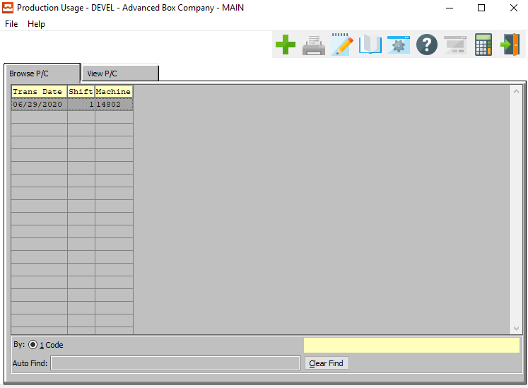

#### Step Two: Add a New Machine/Usage

To add a new order, the user can quickly press the ***“Green + Icon”*** at the top to the screen.



Alternatively, the user can move to the *View P/C* tab, and click the ***“Add”*** button in the middle of the screen.

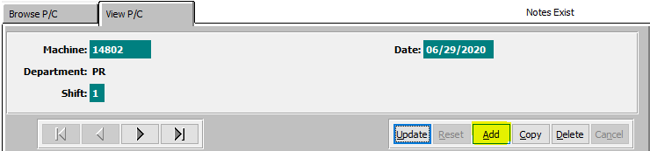

The user can also add a new Usage Transaction by pressing the ***“Add”*** button at the bottom of the screen.

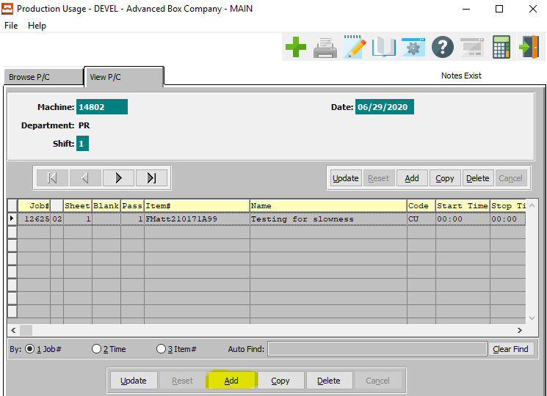

#### Step Three: Verify Machine Usage Information

The user may now take this opportunity to update or change any available Machine or Transaction Fields. For any questions concerning specific Order Fields, the user may refer to the ***“Data Collection Manual”***.

#### Step Four: Save Machine Usage Information

Once the user is satisfied with all of the information within this new Machine or Usage Transaction, they may click the ***“Save”*** button under the former or the latter sections in order to save the information to the system.

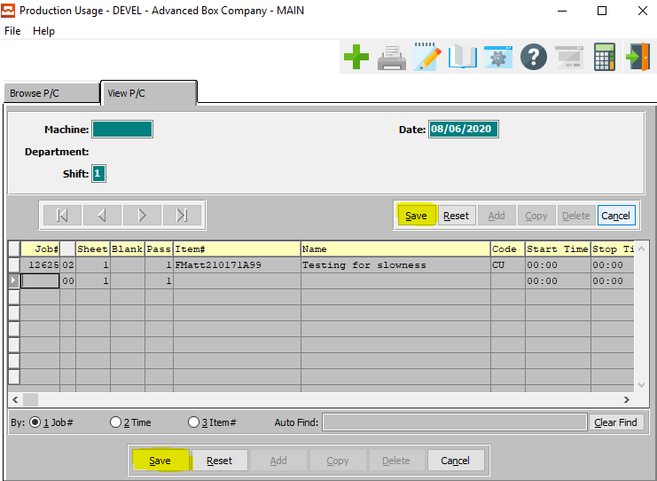

### Production Posting Edit List

The *Production Posting Edit List* shows the total hours for each machine so that any data entry errors may be caught.

#### Step One: Open Edit List Screen

The *WIP Edit List* screen is located in the following Menu Path: Data Collection -> WIP Hours Preposted Edit List. Alternatively, the user can quickly get to this screen using Hot Key combination: ***[“D” – “W”]***.

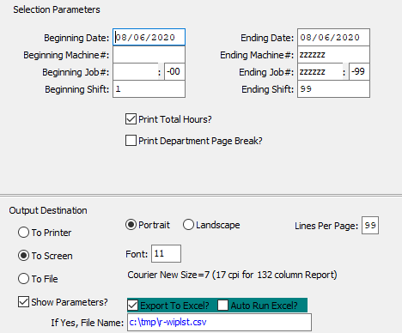

#### Step Two: Select Works in Process

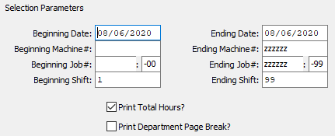

The user may now input their selection parameters as to which works in process they wish to edit. Multiple works in process can be edited at the same time, as the user can enter the beginning and ending selections into their desired fields. Works in process within those parameters will be available for editing.

The user may now take this opportunity to check any toggle boxes for other special rules that they wish for the works in process. For any questions concerning specific rules, the user may refer to the ***“Data Collection Manual”***.

### Posting Production Data

Posting the production will update the job cost file with actual hours.

#### Step One: Open Transfer Screen

The *Transfer WIP to Job Cost* screen is located in the following Menu Path: Data Collection -> Transfer WIP to Job Cost. Alternatively, the user can quickly get to this screen using the Hot Key combination: ***[“D” – “T”]***.

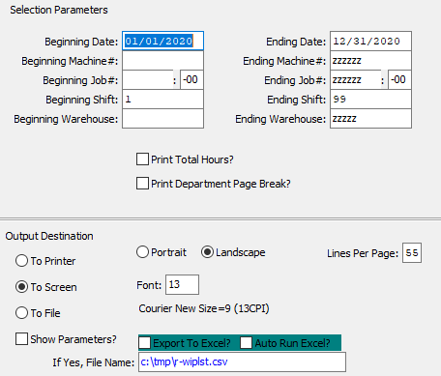

#### Step Two: Select Works in Process

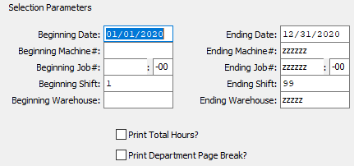

The user may now input their selection parameters as to which works in process they wish to transfer. Multiple works in process can be transferred at the same time, as the user can enter the beginning and ending selections into their desired fields. Works in process within those parameters will be available for transfer.

The user may now take this opportunity to check any toggle boxes for other special rules that they wish for the works in process. For any questions concerning specific rules, the user may refer to the ***“Data Collection Manual”***.

### Data Collection Inquiry

*Data Collection Inquiry by Job* will show all estimated vs. actual hours.

#### Step One: Open Edit List Screen

The *W.I.P. Posting Edit List* screen is located in the following Menu Path: Data Collection -> Reports for Data Collection -> WIP Job Audit Trail. Alternatively, the user can quickly get to this screen using the Hot Key combination: ***[“D” – “R” – “8”]***.

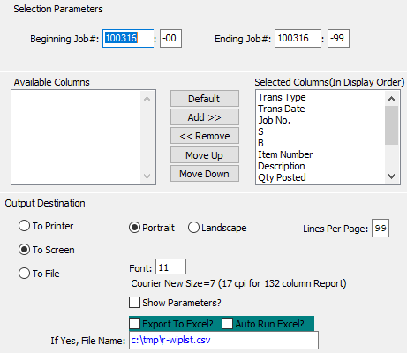

#### Step Two: Select Works in Process

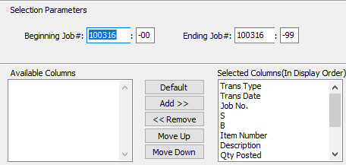

The user may now input their selection parameters as to which works in process they wish to edit. Multiple works in process can be edited at the same time, as the user can enter the beginning and ending selections into their desired fields. Works in process within those parameters will be available for editing.

The user may now take this opportunity to check any toggle boxes for other special rules that they wish for the works in process. For any questions concerning specific rules, the user may refer to the ***“Data Collection Manual”***.

### Job Audit Trail

*WIP Audit Trail* shows transactions posted to the job.

#### Step One: Open Job Audit Trail Screen

The *W.I.P. Job Audit Trail List* screen is located in the following Menu Path: Job Costing -> Reports for Job Costing -> W.I.P. Audit Trail. Alternatively, the user can quickly get to this screen using the Hot Key combination: ***[“J” – “R” – “1”]***.

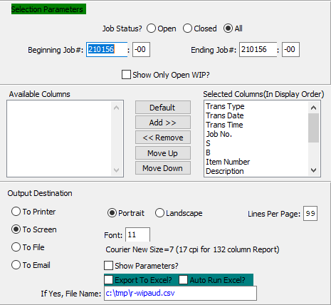

#### Step Two: Select Works in Process

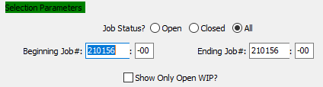

The user may now input their selection parameters as to which works in process they wish to audit. Multiple works in process can be audited at the same time, as the user can enter the beginning and ending selections into their desired fields. Works in process within those parameters will be available for auditing.

The user may now take this opportunity to check any toggle boxes for other special rules that they wish for the works in process. For any questions concerning specific rules, the user may refer to the ***“Job Costs Manual”***.

### Job Summary

#### J R 3

*Job Summary* shows all transactions on 8-1/2 x 11 page.

#### Step One: Open Job Summary Screen

The *Job Summary Analysis Report* screen is located in the following Menu Path: Job Costing -> Reports for Job Costing -> Job Summary. Alternatively, the user can quickly get to this screen using the Hot Key combination: ***[“J” – “R” – “3”]***.

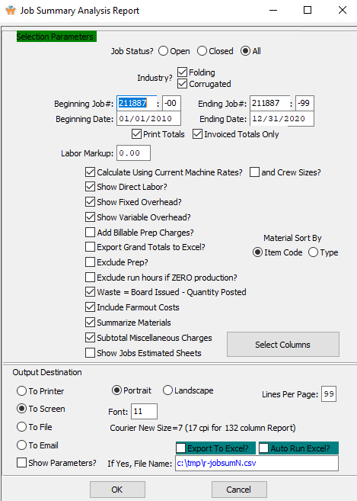

#### Step Two: Select Jobs

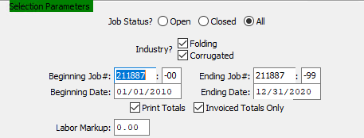

The user may now input their selection parameters as to which jobs they wish to view an analysis for. Multiple jobs can be summarized at the same time, as the user can enter the beginning and ending selections into their desired fields. Jobs within those parameters will be available for review.

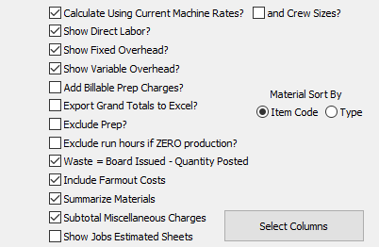

The user may now take this opportunity to check any toggle boxes for other special rules that they wish for the desired jobs. For any questions concerning specific rules, the user may refer to the ***“Job Costs Manual”***.

### Production Reports

Many production reports show machine efficiencies by job number.

#### Step One: Open the Desired Inquiry Screen

The *Reports for Data Collection* screens are located in the following Menu Path: Data Collection -> Reports for Data Collection. Alternatively, the user can quickly get to these screens using the Hot Key combination: ***[“D” – “R”]***.

Current report programs are as follows:

|  |  |  |  |
| --- | --- | --- | --- |
| DR1 | Machine Efficiency | DR9 | Materials Allocation |
| DR2 | Machine Blocking Analysis | DR) | Open Jobs by Due Date/Customer |
| DR3 | Production Department | DR! | Scrap Report |
| DR4 | Production by Machine | DR@ | Scrap Report by Machine |
| DR5 | Data Collection Waste by Department | DR# | Machine Backlog by Kicks |
| DR6 | Labor Hours vs. Estimated | DR$ | WIP Standards Detail |
| DR7 | Labor Hours by Charge Code | DR% | On-Time Deliveries for Jobs |
| DR8 | WIP Job Audit Trail |  |  |

## Finished Goods Control

### Add Finished Goods Receipt

*Finished Goods Receipts* are automatically created via the quantity posted during production on the last machine operation if the ***N-K-AUTOPOST*** flag is set to ***“Yes”***. For example, if the gluer is the last machine, the quantity posted on the gluer will update the receipts file. As an alternative, the receipts may be entered manually.

#### Step One: Open Finished Good Receipt Screen

The *Warehouse Transaction Receipt (Finished Goods)* screen is located in the following Menu Path: Inventory/Finished Goods -> Update Warehouse Transactions -> FG Enter/Modify Receipts. Alternatively, the user can quickly get to this screen using the Hot Key combination: ***[“I” – “U” – “1”]***.

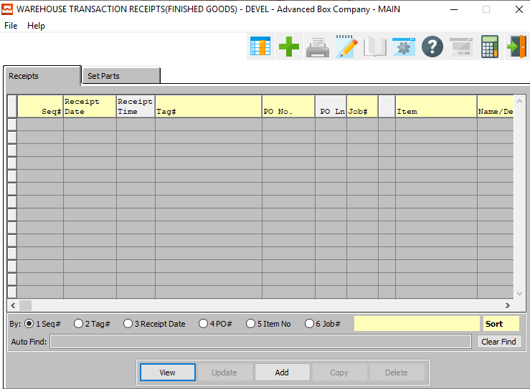

#### Step Two: Add a New Finished Good Receipt

To add a new receipt, the user can quickly press the ***“Green + Icon”*** at the top to the screen.



Alternatively, the user can click the ***“Add”*** button at the bottom of the screen.



#### Step Three: Verify Receipt Information

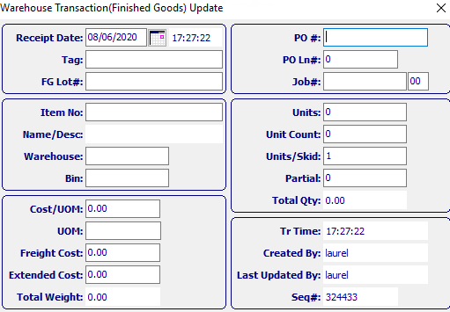

The user may now take this opportunity to update or change any available receipt Fields. For any questions concerning specific receipt Fields, the user may refer to the ***“Finished Goods Manual”***.

#### Step Four: Save Item

Once the user is satisfied with all of the information within this new receipt, they may click the ***“Floppy Disc Icon”*** button at the bottom of the screen to save the XXX to the system.



### Post Finished Good Receipts

*Finished Goods Receipt Transactions* must be posted so that the on-hand quantity is increased, the job quantity on order is decreased, and debits and credits to finished goods and work in process are posted.

#### Step One: Open Finished Goods Posting Screen

The *Finished Goods Posting* screen is located in the following Menu Path: Inventory/Finished Goods -> Update Warehouse Transactions -> Post to Finished Goods Files. Alternatively, the user can quickly get to this screen using the Hot Key combination: ***[“I” – “U” – “5”]***.

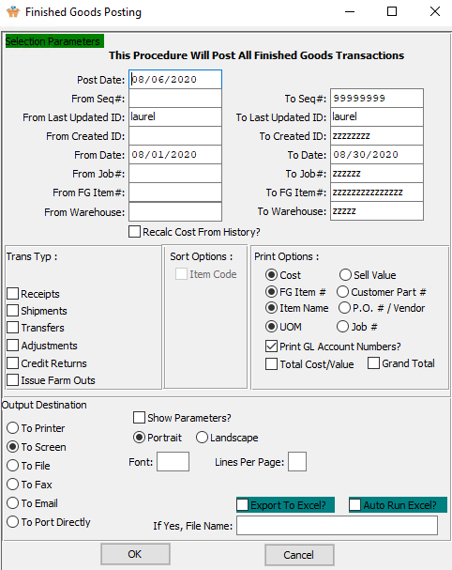

#### Step Two: Posted Selected XXX

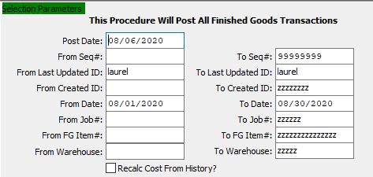

The user may now input their selection parameters as to which Finished Good Items that they wish to post. Multiple Finished Goods can be posted at the same time, as the user can enter the beginning and ending selections into their desired fields. Finished Goods within those parameters will post to the Finished Goods files.

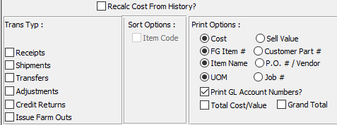

The user may now take this opportunity to check any toggle boxes for other special rules that they wish for the desired Finished Goods. For any questions concerning specific rules, the user may refer to the ***“Finished Goods Manual”***.

## Order Processing – Releases (Optional)

### Release an Item

#### Step One: Find Order

If the user is coming back to this new order at a later time, or releasing items from a previous order, they must first find the correct order. To do this, the user must go back to the *Order Maintenance* screen, which is located in the following Menu Path: Order Processing -> Update/Add Orders -> Order Entry. Alternatively, the user can quickly get to this screen using the Hot Key combination: ***[“O” – “U” – “1”]***.



On the *Browse Order* tab, which is the first to open, the user may search for the order from the list of browsable orders. The user may use any of the search fields at the top of the *Browse* screen in order to narrow down their search list.

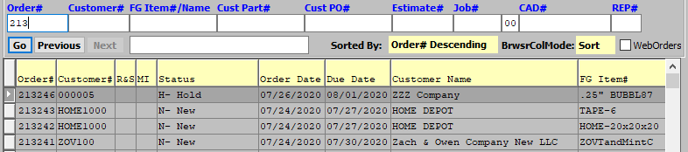

Once the user has found their desired Order, they may click on it in order to highlight it in the list. The highlighted order will populate the other system tabs so that the user may review or update the detailed information for the order.

#### Step Two: Go to the Items Tab

With the desired order highlighted in the *Browse* screen, the user may click on the *Items* tab in order to view detailed information about the item(s) within this order.

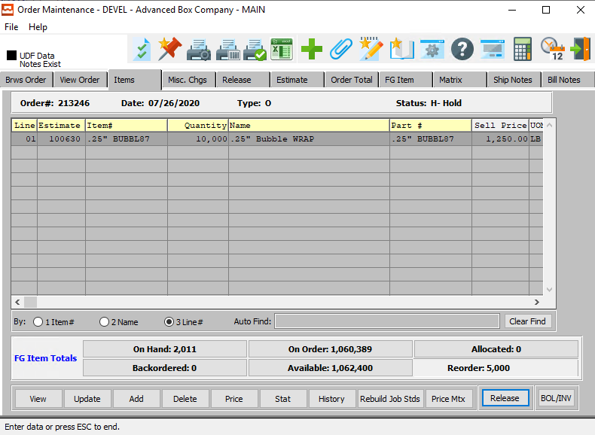

On this screen, the user may update the currently selected item by clicking the ***“Update”*** button at the bottom of the screen. They may also add or delete items from the order on this tab as desired.



#### Step Three: Release Item

In order to release an item within an order, the user must first make sure that the desired item is highlighted within the list of items. Only highlighted items will be affected, and the user can only select one item at a time.

The user may click the ***“Release”*** button on the bottom of the screen to create a release for the currently selected item.



The user may then be prompted with a multi-question popup screen. This will be asked of the user if there is an item within the order that is connected to an estimate that was copied to the current order from an existing customer estimate.

First, it will ask the user if they wish to merge all of the items within the order. If the user wishes to do so, they must ensure that the *Prompt to merge each item* toggle box is checked.

The popup screen will also ask the user if they wish to merge items within this order with a previously existing release. If the user wishes to merge these items, they must ensure that the *Merge items with existing release* toggle box is checked.

Once the user has answered these questions, either by checking or unchecking the two toggle boxes, they may answer they main question of this popup box. If the user wishes to create a release and a Ship ID for this item, they may click the ***“Yes”*** button at the bottom of the popup screen.

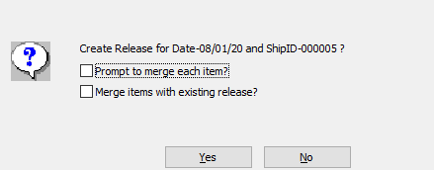

Once the user has decided to release the item(s), they will be asked if they wish to select bins and tags for the release.

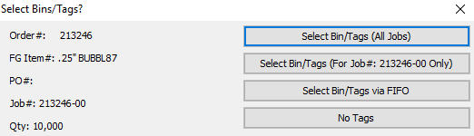

If the user wishes not to select tags here, they may click the ***“No Tags”*** button. This will release the item without any further prompts to the user at this time.

### Find the Release

#### Step One: Open Order Release Screen

The *Order Release* screen is located in the following Menu Path: Order Processing -> Tickets for Releases -> Enter/Edit Releases. Alternatively, the user can quickly get to this screen using the Hot Key combination: ***[“O” – “T” – “1”]***.

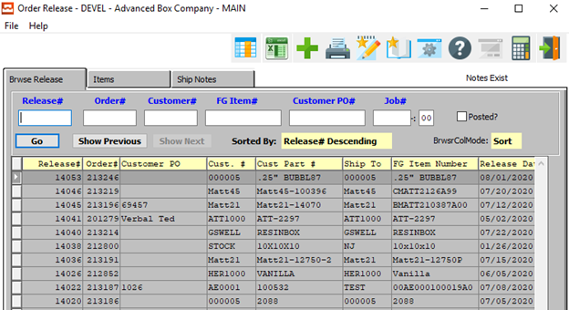

#### Step Two: Find Release

On the *Browse Release* tab, which is the first to open, the user may search for the release from the list of browsable releases. The user may use any of the search fields at the top of the *Browse* screen in order to narrow down their search list.

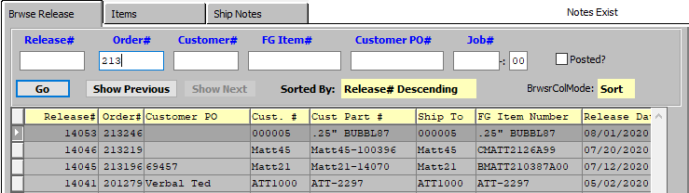

Once the user has found their desired Release, they may click on it in order to highlight it in the list. The highlighted release will populate the other system tabs so that the user may review or update the detailed information for the release.

#### Step Three: Go to the Items Tab

With the desired release highlighted in the *Browse* screen, the user may click on the *Items* tab in order to view detailed information about the item(s) within this release.

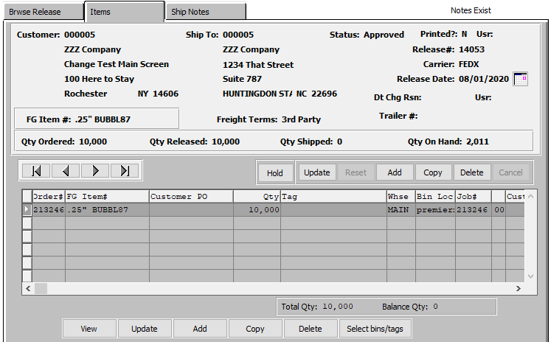

On this screen, the user may update the currently selected item by clicking the ***“Update”*** button at the bottom of the screen. They may also add or delete items from the release on this tab as desired.

#### Step Four: Select Bins/Tags

The user may click the ***“Select Bins/Tags”*** button at the bottom of the screen in order to select the bins and tags for the highlighted item on the release.



The user will then be prompted to verify if they wish to select bins for all jobs via a popup screen. Click the ***“Yes”*** button in order to do so.

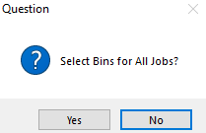

The user may now select which bins they wish to pull the item inventory from. This will make sure that inventory is pulled from the correct location.

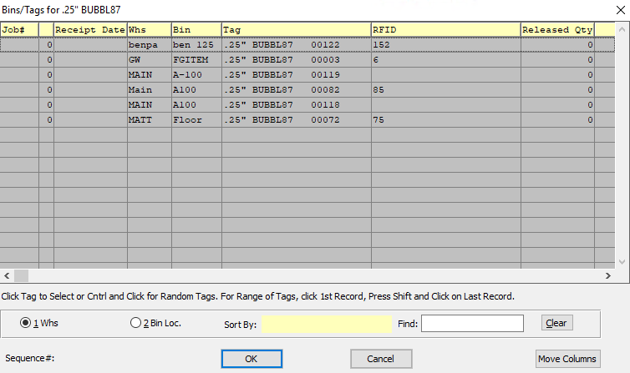

The user may select multiple bins by using the ***“Control-Click”*** method to highlight multiple bins within the list of those available. Only those bins that are highlighted by the user will be used for this release.

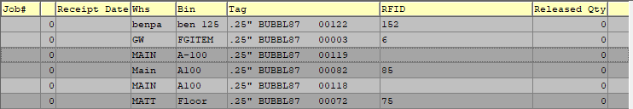

Once the user has selected their desired bins for this release, the release will update the item lines, the total quantity on the release, and the balance quantity of the order.

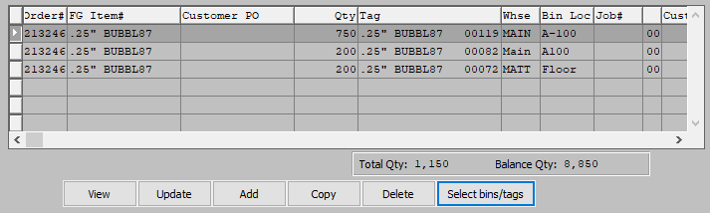

### Print Pick Ticket

#### Step One: Open Release Ticket Screen

The *Release Ticket* screen is located in the following Menu Path: Order Processing -> Tickets for Releases -> Print Release Tickets. Alternatively, the user can quickly get to this screen using the Hot Key combination: ***[“O” – “T” – “3”]***.

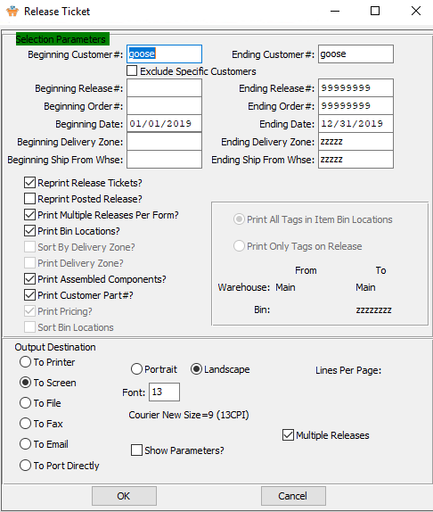

#### Step Two: Print Selected Order/Release

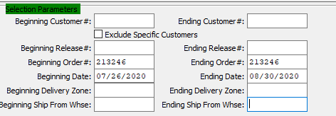

The user may now input their selection parameters as to which orders or releases they wish to print. Multiple release tickets can be printed at the same time, as the user can enter the beginning and ending selections into their desired fields. Releases within those parameters will print tickets.

If the user is attempting to reprint Release Tickets that have previously been printed, they must make sure that the *Reprint Release Tickets* toggle box is checked.

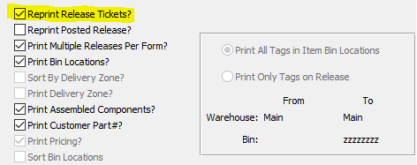

The user may now take this opportunity to check any toggle boxes for other special rules that they with the tickets to follow. For any questions concerning specific rules, the user may refer to the ***“Order Processing Manual”***.

### Post Pick Ticket

#### Step One: Open Release Posting Screen

The *Release Posting/Create BOL* screen is located in the following Menu Path: Order Processing -> Tickets for Releases -> Create Bill of Lading. Alternatively, the user can quickly get to this screen using the Hot Key combination: ***[“O” – “T” – “4”]***.

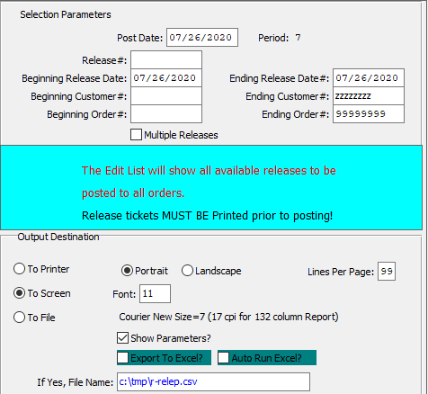

#### Step Two: Post Selected Order/Release

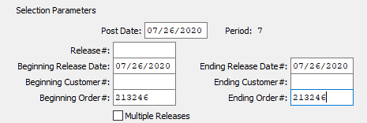

The user may now input their selection parameters as to which orders or releases they wish to post. Multiple release tickets can be posted at the same time, as the user can enter the beginning and ending selections into their desired fields. However, the user must make sure that the *Multiple* Release toggle box is checked in order to do so. Releases within those parameters will post Bills of Lading.

Please Note: Release Tickets must be printed prior to the user attempting to post a Bill of Lading.

## Order Processing – Bills of Lading

### Locate Bill of Lading

#### Step One: Open Bill of Lading Screen

The *Bill of Lading Maintenance* screen is located in the following Menu Path: Order Processing -> Shipping/Bill of Lading -> Enter/Edit BOL. Alternatively, the user can quickly get to this screen using the Hot Key combination: ***[“O” – “S” – “1”]***.

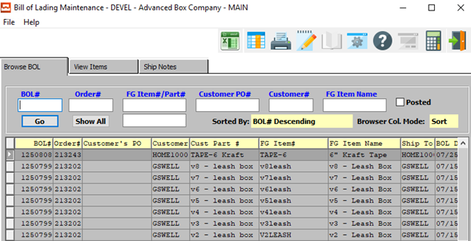

#### Step Two: Find Bill of Lading

On the *Browse BOL* tab, which is the first to open, the user may search for the Bill of Lading from the list of browsable BOL’s. The user may use any of the search fields at the top of the *Browse* screen in order to narrow down their search list.

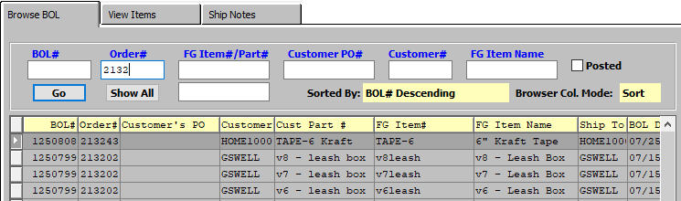

Once the user has found their desired Bill of Lading, they may click on it in order to highlight it in the list. The highlighted BOL will populate the other system tabs so that the user may review or update the detailed information for the Bill of Lading.

#### Step Three: Go to the View Items Tab

With the desired Bill of Lading highlighted in the *Browse* screen, the user may click on the *View Items* tab in order to view detailed information about the item(s) within this Bill of Lading.

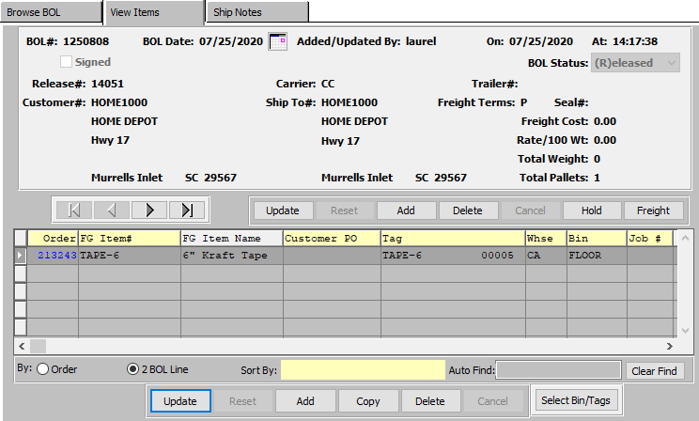

On this screen, the user may update the currently selected item by clicking the ***“Update”*** button at the bottom of the screen. They may also add or delete items from the release on this tab as desired.

The user also has the option to change any information within the main order by clicking the ***“Update”*** button in the middle of the screen, near the main order information area.

Please Note: If the user does make changes to the current Bill of Lading, the order will be placed On-Hold. In order to avoid having to reprint the Bill of Lading, the user can click the ***“Hold/Release”*** button to quickly change the order status.



### Post Bill of Lading

#### Step One: Open Release Posting Screen

The *BOL Posting/Create Invoice* screen is located in the following Menu Path: Order Processing -> Shipping/Bill of Lading -> Post BOL/Create Invoice. Alternatively, the user can quickly get to this screen using the Hot Key combination: ***[“O” – “S” – “5”]***.

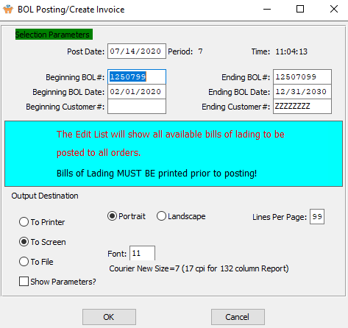

#### Step Two: Post Selected Order/Release

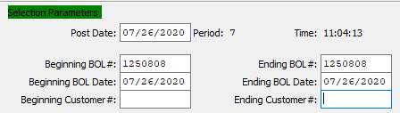

The user may now input their selection parameters as to which bills of lading they wish to post. Multiple BOL’s can be posted at the same time, as the user can enter the beginning and ending selections into their desired fields. Bills of Lading within those parameters will create invoices.

Please Note: Bills of Lading must be printed prior to the user attempting to post.

## Order Processing – Invoicing

### Locate Invoice

#### Step One: Open Invoice Screen

The *Invoice Maintenance* screen is located in the following Menu Path: Order Processing -> Billing/Counter Sales -> Enter/Edit Invoices. Alternatively, the user can quickly get to this screen using the Hot Key combination: ***[“O” – “B” – “1”]***.

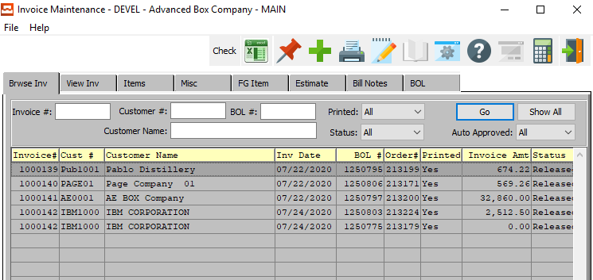

#### Step Two: Find Invoice

On the *Browse Invoice* tab, which is the first to open, the user may search for the Invoice from the list of browsable Invoices. The user may use any of the search fields at the top of the *Browse* screen in order to narrow down their search list.

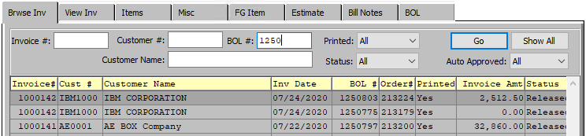

Once the user has found their desired Invoice, they may click on it in order to highlight it in the list. The highlighted invoice will populate the other system tabs so that the user may review or update the detailed information for the invoice.

Please Note: The system does not assign an invoice number until that invoice has been printed.

### Print Invoice

#### Step One: Open Invoicing Screen

The *Invoicing* screen is located in the following Menu Path: Order Processing -> Billing/Counter Sales -> Print OE Invoices. Alternatively, the user can quickly get to this screen using the Hot Key combination: ***[“O” – “T” – “3”]***.

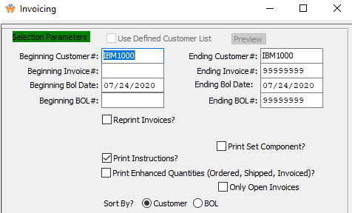

#### Step Two: Print Selected Invoice

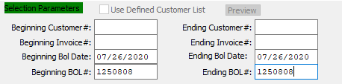

The user may now input their selection parameters as to which orders or releases they wish to print invoices for. Multiple invoices can be printed at the same time, as the user can enter the beginning and ending selections into their desired fields. Invoices within those parameters will print.

If the user is attempting to reprint Invoices that have previously been printed, they must make sure that the *Reprint Invoices* toggle box is checked.

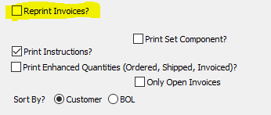

The user may now take this opportunity to check any toggle boxes for other special rules that they with the invoices to follow. For any questions concerning specific rules, the user may refer to the ***“Order Processing Manual”***.

### Post Invoice

#### Step One: Open Invoice Posting Screen

The *Invoice Posting* screen is located in the following Menu Path: Order Processing -> Billing/Counter Sales -> Invoice Post/Update GL. Alternatively, the user can quickly get to this screen using the Hot Key combination: ***[“O” – “B” – “4”]***.

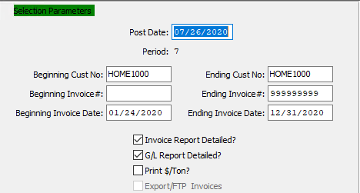

#### Step Two: Post Selected Invoice

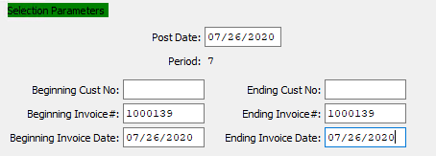

The user may now input their selection parameters as to which invoices they wish to post. Multiple Invoices can be posted at the same time, as the user can enter the beginning and ending selections into their desired fields. Invoices within those parameters will post.

Please Note: Invoices must be printed prior to the user attempting to post. The system will prompt the user to this rule via a popup message when they open the *Invoice Posting* screen.

